Design Studio 1 (part 2)

Discussion 9am Team #5

***EXECUTIVE SUMMARY***

Our team intends to approach the design of the *TeachEveryone* software by making use of the design principles and techniques we learned in class this quarter. We will have a continuous dialogue involving the goals, constraints, assumptions, decisions, opinions, and ideas in the process of developing this design model. The team will take into consideration the main design by focusing on application, interaction, and architectural design aspects in the context of fit-for-purpose (what is desired by our audience and stakeholders) as well as what is pragmatic considering the knowledge and resources available. We look to employ expert practices by continually reminding ourselves of the essence of the problem at hand, by looking for solutions that already exist, pointing out our knowledge gaps, and working as a team to come up with the best design solution that we can for *TeachEveryone*. This software product is intended to unite in-person students and staff with their remote counterparts in such a way that the physical-in-class user experience can be extended as best as possible to remote students and other users.

***01 - AUDIENCE AND OTHER STAKEHOLDERS***

For the *TeachEveryone* project, we have determined our users and stakeholders through team collaboration. By this we mean those who will be directly interacting with the software, and those who have a vested interest in seeing this software come to fruition, respectively.  
  
Concerning our potential users, we envision them as:

* The Teachers/Professors of Courses at UCI
  + due to the teacher’s/professor’s experience and knowledge-input toward the development of a software solution for the *TeachEveryone* project. This role would likely utilize the software more than any other audience member.
* The Teacher’s Aids
  + due to their need to interact with the software on a regular basis for the purpose of assisting students with their coursework.
* The Teacher’s Reader/Grader
  + due to their need to review and grade coursework submitted by students.
* The In-Class/Physically-Present Students
  + due to their need to participate in lectures, quizzes, exams, collaboration (group-work) with the teacher, the teacher’s aids, and other students both in-person and/or remotely.
* The Students Learning and Participating Remotely
  + due to their need to participate in lectures, quizzes, exams, collaboration (group-work) with the teacher, the teacher’s aids, and other students remotely.

And concerning our potential stakeholders, we have ascertained that they will be comprised of the following:

* UCI's Office of the Vice Provost for Teaching and Learning
  + due to this office being the initiator of the *TeachEveryone* goal and subsequent endeavor. Furthermore, The software would need sufficient funding to be developed. The funding could also increase or decrease depending on the success of the software.
* The Teachers/Professors of courses at UCI
  + due to the teacher’s/professor’s experience and knowledge-input to other stakeholders as to the course of action in implementing the *TeachEveryone* project.
* UCI’s Office of Information Technology (OIT)
  + due to their oversight in the implementation of a proposed solution to the united in-class & remote teaching environment from a practical and technical standpoint.
* UCI Office of Student Affairs
  + due to their position in assisting students in meaningful ways to help them in succeeding with their choices toward academic success (e.g in-person learning vs remote, and class availability based on the current options provided by each course).
* Other Universities in the UC system
  + due to the possibility of other UC campuses desiring to replicate the outcome of the project, if successful, and implement their own version of the software.
* Campus Workers
  + With the new software, there may need to be changes to the responsibilities of campus workers. With the inclusiveness of *TeachEveryone*, it’s likely to see an increasing amount of students choose to commute rather than living on/near campus. Therefore, there could be a potential shift from in-person to virtual job roles such as online regulation and security.
* Students’ Parents
  + Many parents would be interested in their children being able to receive the same participation both in-person and online. Many families would benefit if the student can stay home while also receiving the same education.
* Prospective Students
  + *TeachEveryone* can also make an impact on prospective students' college decisions. It can play an important role on whether or not the prospective student chooses to attend UCI and their decision on being a commuter.

***02 - GOALS, CONSTRAINTS, ASSUMPTIONS FOR THE OVERALL DESIGN SOLUTION***

Our primary goal is to find a solution to the essence of the problem at hand. In this case we are designing with the purpose of bringing about the *TeachEveryone* platform in a way that satisfies the needs of those who would participate in a joint in-class and remote teaching/learning environment. Of course there will be limitations to what resources we can make use of as a team, and there will be assumptions made along the way that we need to be made conscious of.

* Goals
  + **Provide an equal learning environment for both in-person and remote students:** In order to ensure a safe return to campus as well as ease the concerns of students about the transition from online classes back to normal in-person instructions, *TeachEveryone* will provide an equal learning experience with the flexibility in class’s participation and activities for both in-person and remote students. Due to different situations and limitations of students when attending classes during this post-pandemic period, a variety of learning approaches on the app will be provided and utilized.
  + **Be inclusive for student and instructor:** In the optimization of teaching and learning experience, the application requires both students and instructors to get involved in directly using it. Since conveying information, knowledge and communication in this case, is the ultimate goal of teaching and learning among users, this process can be simplified and operated more effectively when everyone is in the same place (through the app). In other words, *TeachEveryone* prioritizes the inclusive environment presenting contents and functionalities that ensures the accessibility and comprehension of all students and instructors.
  + **Allow students to contact and interact with instructors as well as other students:** *TeachEveryone* will provide a communication environment between students and instructors for learning and consulting purposes. Since students might have questions and confusions related to course’s material during the learning process, we will provide a means for students to communicate with their instructors to ease their concerns. Students will also be able to contact and interact with other fellow students in class as they might need to work in a group or participate in discussion.
  + **Offer a more personal approach:** *TeachEveryone* caters to each student’s pace and learning style, creating a more comfortable environment for both in-person or online learners. If the learners are struggling with a particular topic, they can reach out to complementary web resources or get quick help from their instructor.
  + **Allow instructors to create the class content and organize the class structure:** *TeachEveryone* will allow instructors to set up their course’s materials and class structure since different classes might have different requirements and contents. Functional features of the app could be adjusted due to the needs and preferences of instructors for the class structure.
* Constraints
  + ***TeachEveryone* must use Duo Security System which requires UCInetID for login purposes:** For the safety and security of user’s personal data, *TeachEveryone* must be supported by the Duo Two Factor Authentication system using UCInetID. Having the identification of users verified at the login step would ensure that the information of UCI students and instructors is carefully preserved and protected.
  + ***TeachEveryone* must be operated on both the web-based platform and mobile app:** To serve the convenience of *TeachEveryone*’s users, the app will be developed on both web platforms and mobile apps. Users can get access to *TeachEveryone* on any of the devices they would like to.
  + ***TeachEveryone* must be launched in the Fall 2022:** To give immediate assistance and support to students and instructors during the transition from remote to in-person learning/teaching, *TeachEveryone* needs to be completed and operated starting from the Fall quarter 2022. The app must meet the product timeline in order to assist and ease the concerns and confusions of everyone when attending/operating classes during the post-pandemic period.
  + ***TeachEveryone* must be accessible via any public network connection:** To support instructors and students with availability and flexibility in their learning and teaching process, *TeachEveryone* can be accessible anytime and from any location with public network connection.
  + ***TeachEveryone* must connect with the school email system:** The app must link to the school email system since students might need to receive notifications related to the class activities.
  + ***TeachEveryon*e must be stable and fast when operating on a large scale:** Since we’re expecting to serve all the UCI students and faculty staff without any interruption or glitch during their learning/teaching process, *TeachEveryone* must be developed to work stably and quickly in response even with a high number of users.
  + **To access *TeachEveryone*, user’s devices must have Internet access or WiFi connection:** Users must be connected to the Internet in order to interact with active features and functions of *TeachEveryone*. Students can download the content of the class while having WiFi connection and then view it offline, but instructors need to have Internet access to make changes to the class structure.
  + **The UI versions of web-based platforms and mobile apps might have different layouts:** Due to the differences in the displaying screen and interaction of users with mobile phones versus computers, the layouts of *TeachEveryone* on the web platform might be different. Since most mobile phones support touch-interaction, some features of *TeachEveryone* on phones would not behave as similar as on the web platform.
* Assumptions
  + **Once launched, *TeachEveryone* will be used by all instructors, students, and in all classrooms:** *TeachEveryone* should be used in every classroom in order to boost synchronous and efficient learning for every student.
  + **All users have access to Internet or WiFi:** Since the app only operates when connecting to the Internet or WiFi, user’s devices must be connected to any public network or cellular network data.
  + **Professors have sufficient technical skills:** Functional features of the app would require instructors to have some knowledge of using technology as they would need to set up the class content and instruction. Some features could be hidden or shown based on the necessity of class activities and structure.
  + **In-person classes also use and utilize the features of *TeachEveryone* to facilitate classes for remote students:** To provide an equal learning environment for every student, in-person structured classes should use *TeachEveryone* in order to facilitate classes for remote learning. Online learning students would still be able to attend lectures through recordings of the actual classes, participate in group works, and join discussions through the *TeachEveryone* app.
  + ***TeachEveryone*’s users already set up Duo Authentication:** Since logging into *TeachEveryone* requires Duo Authentication for safety and security reasons, UCI students and instructors must use their UCInetID to access the app.
  + **All users have stable access to a digital device:** It’s essential that all users have at least one stable access to technology. Both virtual and in-person learning environments will rely on *TeachEveryone* to provide an inclusive teaching approach which can only be accessed through a digital device.

***03 - MAIN DESIGN***

The core of our design effort consists of laying out the details of an application that will incorporate the use of existing video-conferencing technology into a new software package that will be made available to commonly used OS platforms, both desktop/laptop and mobile. This also includes a practical user-interface adaptable to each device. We intend to provide a scalable architecture in the event that other UC campuses may decide to incorporate the *TeachEveryone* software.

* Application
  + **Facilitate teaching a class:** *TeachEveryone* shall be utilized during lecture time to support a flexible and inclusive teaching environment. Students will be able to equally interact and participate in class both in-person and virtual. Through the *TeachEveryone* platform, professors will be able to guide and monitor students to follow along with the lecture and participate in lecture activities through *TeachEveryone*.
  + **Support group activities and interactions during lecture:** *TeachEveryone* can organize students into groups when the professors assign group activities. In addition, *TeachEveryone* can be used to assign work and surveys to students during class. Similar to the functionalities of Iclickers for students to respond to professors' questions.
  + **Enable User Notifications:** Users can choose to opt in/out of system notifications. Users can choose to get notified about course due dates, lecture notifications, discussion replies, announcement and changes made to course material.
  + **Support live lecture/discussion recordings**: *TeachEveryone* can be used to record class lessons and other lecture materials for students to review on and provide useful tools such as subscripts, translations and dictionaries. Furthermore, *TeachEveryone* will save backup copies of past lectures for cases where professors misplace material or when students lose their work.
  + **Support an online discussion forum (Future Versions):** To provide better interaction, *TeachEveryone* can offer advanced collaboration tools such as online discussions, quick messages and feedback from instructors and peers. Students can use *TeachEveryone* as a side communication tool to facilitate peer interactions like having class group chats or private chats. *TeachEveryone* can also support a question/discussion system where students can post questions in real time where professors/TA's can respond to. The questions and answers can be made public for all students to view.
  + **Support class-class collaboration (Future Versions):** *TeachEveryone* can offer course collaborations for when different teachers are teaching the same course. They can have the option to combine learning materials. In addition teachers can choose to link and provide their past teachings for students to reference to.
  + **Support the use of a lockdown browser (Future Versions)**: *TeachEveryone* can provide a secure testing environment where the students taking the exam online will be restricted to only using *TeachEveryone*'s exam page during exams to prevent cheating. *TeachEveryone* can also monitor students progress and unusual activities to prevent academic dishonesty.
  + **Have focus modes and other accessories to support learning (Future Versions)**: *TeachEveryone* can allow users to enter studying modes where students will be banned from going on entertainment websites and applications. This feature can be used by professors during exams or also when students themselves want to focus without being distracted.
* Interaction
  + **User Interface (UI):** The UI will comprise various screen layouts that can be adjusted to accommodate different devices and/or varying scenarios. Screen layout options will vary according to the type of device used. A user, for example, will be able to view the instructor, and other participants simultaneously with the ability to select which meeting participants the user wants to focus on. The ability to auto-select an individual speaker based on audio input will be a feature. Touch screen enabled devices will allow for well-established gestures to navigate the GUI. The intention here is to provide familiar ways of interfacing with a GUIi in order that the learning curve will be diminished.
  + **Privacy Options:** Users will be able to have the option to, like other video-conferencing platforms, to mute their audio and/or stop their video feed immediately upon request.
  + **Screen Layout:** The screen layout for each combination of OS and device-type will contain the following elements:
    - An introductory dashboard that will allow users to create or join a meeting along with a button to access the user’s profile, and a button to access the settings dialogue.
    - A main toolbar that will have buttons to:
      * create/join a meeting
      * create/join a sub-group of the current meeting (e.g for breakout rooms)
      * to exit the current interaction-level (general meeting, subgroup, personal chat) and return to the previous level or exit if the level is general meeting
      * mute/unmute video
      * start/stop video
      * share screen
      * share file
      * raise hand
    - The main screen for video-conferencing will contain icons to allow for various screen layouts to provide the user the option to:
      * view the instructor alone (default)
      * view the current speaker only
      * view the instructor and current speaker side-by-side
      * view the the current speaker along with the last 5 most recent speakers on the right-side portion of the main screen
      * view all participants in equal-size profile shots highlighting those who are currently speaking
    - A side panel that will include:
      * A settings button to edit the user’s profile, security settings, and other default settings
      * A chat section to see and participate in meeting discussions
      * A section to upload a file to chat

Interaction Design

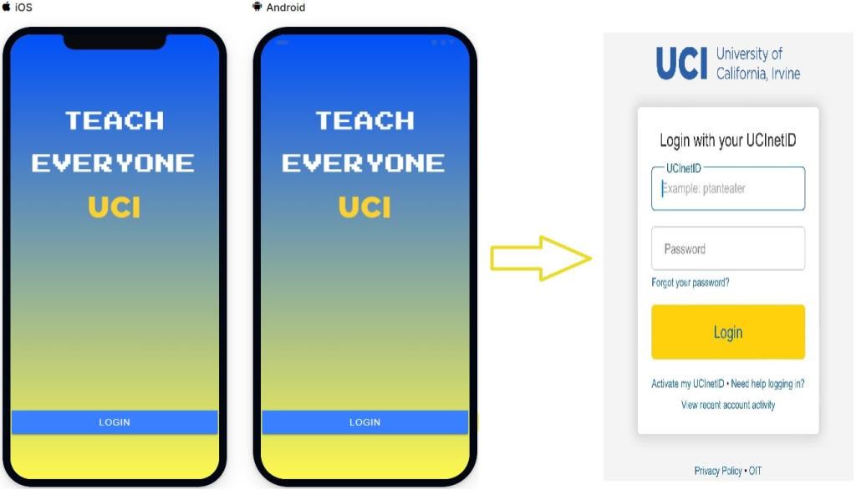

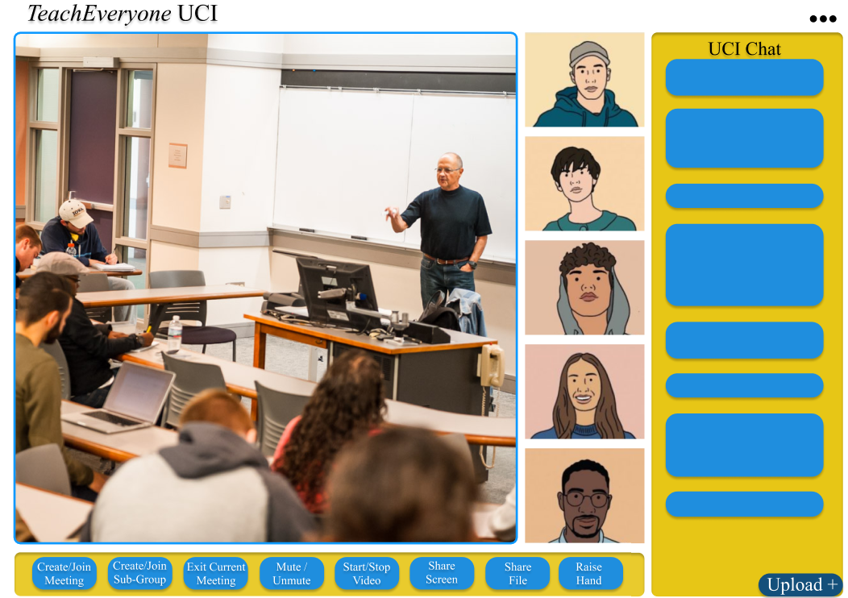

* Architecture
  + The server-side infrastructure
    - A centralized approach will be hosted by UCI’s Office of Information Technology (OIT) managing the servers on the UCI campus. However, the system will make provisions for scalability for the possible expansion to other UC campuses where a distributed architecture will allow for cross-campus interactions.
    - There will be a database server for the purpose of storing and querying records of user-logins, security-credentials, audio and video recordings, file-transfers, error-logging, et al.
    - The UCI servers will require credentials to log-in to the software by modern conventional means in order to participate (see diagram below).
  + The client-side applications
    - Software will be developed to run on Windows, Mac, iOS, and Android. If the need presents itself in the future, a port to Linux will be considered.
    - The application will have desktop/laptop, mobile device, and smartphone versions for the aforementioned operating systems
    - For the recording of audio/video content, a cloud resource of the user's own choosing and the saving of files locally will be options as an alternative to accessing recorded content from OIT servers.
    - Users will authenticate their credentials through the application interface with the UCI servers. Upon success, users will be granted access to meetings and settings. If a user’s credentials are invalid, they will be redirected to the login page (see diagram below).

Architecture Design

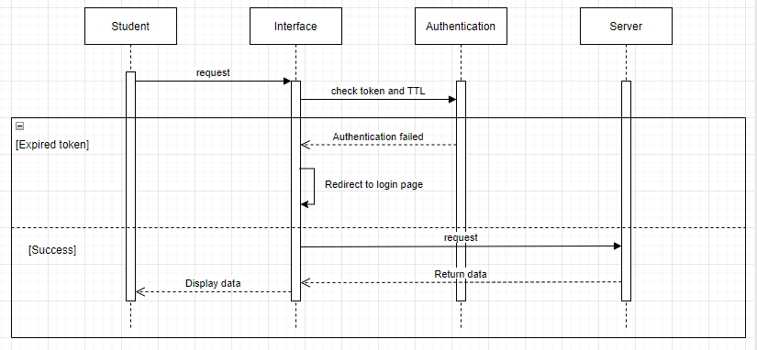

***04 - ALTERNATIVES CONSIDERED***

* **Alternative #1: Supporting iclicker and pop quizzes during lecture and allowing students to create questions for other students to participate in during breakout room discussion.**
* Description: *TeachEveryone* app will have a functionality for instructors/lectures/TAs to populate iclicker or pop quizzes on students’ screen with options for either multiple choice or free response questions. Quiz questions will pop up on the screen one at a time, and are timed in seconds according to the instructors (ex.: 30, 60, 90 seconds). Correct answers and result statistics will be shown to students once the quiz is timeout. Instructors/TAs then can use the results to assign participation credits or quiz grades to the participating students. Students can create questions for other students to participate in during the breakout session.
* Comparison of Approaches: The original version of the *TeachEveryone* app does not have this feature implemented; however, it would take a lot of development time and performance resources to implement the feature across the platform in both instructors’ and students’ interfaces. Therefore, as we plan to shorten the launch time and save resources, we decided to omit this feature for future updates.

* **Alternative #2: Implementing a reward system for the online discussion forum where students can answer other students' questions to get points for purchasing digital gifts.**
* Description: This feature will be similar to the reward system used on online forums like Reddit and Quora where users answer questions of other users and get rewarded points based on their contribution on the forum. Points then can be used to purchase digital items and/or gifts. In order to earn points, students must answer other students’ questions, and they earn points by the amount of upvotes they receive from other students. The items/gifts purchased using points can be sent from students to students.
* Comparison of Approaches: Although this reward system would encourage students to participate in Q/A forums and reduce the need for instructors/TAs to address students’ questions as more students would likely be encouraged to participate in answering questions to get more points, it would not be very beneficial and efficient to implement such complicated and resource intensive feature when considering the effort and time it would have take to design and implement such a big feature. This reward system would require a large database storage to store all the points received by students, the number of upvotes each student received, and the designs of the items/gifts that can be purchased using points. Therefore, we decided not to include a reward system in our forum design.
* **Alternative #3: Integration of a third-party calendar API to show upcoming conference calls.**
* Description: A third-party calendar integration which will display the upcoming conference/lecture sessions. This feature will allow students to plan ahead and stay on top of upcoming lectures. The implementation will be using a third-party calendar API like Google Calendar.
* Comparison of Approaches: This approach will most likely replace the need to skim for active conference rooms to join as a calendar of scheduled conference sessions will allow students to see which conference sessions are active to join now. Although it is a more convenient method of organizing lecture sessions, it requires a third-party API which may not always be online and the app is dependable on a third-party to be functional properly. Meanwhile, a custom built calendar for the app would require massive resources and time, and a third-party API may cause the app downtime; since the costs outweigh the benefits, we have decided not to include a custom built or a third-party calendar on our design.
* **Alternative #4: Integrating facial recognition for login instead of Duo Mobile authentication.**
* Description: Replacing the need to manually input UCI login information and accessing Duo Mobile for an authentication code. Provide students with faster access to the app and more convenient ways to login.
* Comparison of Approaches: This approach will allow students to save login time by bypassing the need to manually input UCI login information and open up Duo Mobile to get an authentication code. Although students may find it convenient to access the app, the lack of security may be alarming and needs further research to weigh the risk of facial recognition login. Furthermore, not all devices support this feature and web-based access most likely won’t benefit from this feature. Therefore, we decided to stick with UCI login with Duo Mobile authentication.
* **Alternative #5: Enabling video call notifications similar to a video call from FaceTime or Facebook Messenger when a lecture session is available.**
* Description: This would act as a method to get students to immediately respond to join the lecture sessions without risk missing a lecture session. Saving an alert notification in the form of a phone call notification, students won’t be missing out on important lecture sessions.
* Comparison of Approaches: This feature would be nice to have as a way to notify students of important lecture sessions, however, it may be an unnecessary feature because a normal text pop up notification can do the job just fine. Therefore, we decided to omit it.

***05 - ETHICAL ANALYSIS***

Ethics is an important aspect in the development of software because it’s just like all other projects undertaken by the school. Ethics ensures that what is being built is environmentally friendly, accessible by all students, and is not gender-discriminatory or racist, or allow for any negative aspects. The *TeachEveryone* application is made up of many stakeholders, and it is, therefore, an important aspect to ensure that human values are considered and not risk imminent failure.

* The values that we consider central in the development of our software are:
* Security is a central value because the system involves the use of private data during registration and login; therefore, this data should be safeguarded and confidential to ensure it does not fall into the hands of unauthorized persons. Grading will also be done on the system, and it should be secure enough to prevent the alteration of marks by the students.
* The application should preserve the public image of the institution. It should ensure that its use does not cause a lack of trust. Incidents such as stealing exams should be curbed in the system.
* The system should conform to the set traditions of education. The system should be able to function just as a physical class by allowing teachers to be the host and controlling what goes on in the classroom.
* The system should be durable and exciting. Through the use of up-to-date technologies, the system should be able to stimulate students and teachers and make learning more fun and lively.
* The system should aim to offer all students equal access and opportunity to participate in all forms of activities. Considering marginalized students with disabilities that can’t regularly participate in lectures and be made simple to use for students and professors who aren’t familiar with technology.
* Could this software marginalize, create a barrier for, or embody bias against any particular segment of the population? How can we mitigate this?
  + The *TeachEveryone* program does not feature any characteristics of gender or racial discrimination; nonetheless, it may not be useful to persons with special needs aspects such as braille. This problem could be mitigated by including and supporting accessibility features, such as a screen reader, captions, transcriptions, or voice-control. Making a good UX design is crucial and necessary to mitigate this problem as well because people with special needs benefit greatly from consistency, which is typically a good UX practice. Every user, whether they use sight, touch, or hearing, should have the same experience.
* What are some potential ways the existence of this software may cause harm to people or the environment? How can we mitigate this?
* The *TeachEveryone* software will cause a significant blow in socialization and human interaction. Unlike the physical classes where students and teachers could socialize, the application might cut off a significant amount of in person interaction. This can be solved by allowing professors to create live activities, polls during lectures, and encouraging students to ask questions on both platforms by submitting or using their microphones. Also, while the *TeachEveryone* app does not directly hurt the environment, the increased number of new servers and data centers that consume a considerable amount of electrical energy may negatively impact the environment. We may address this issue by constructing green data centers that employ efficient technology such as low-power servers or utilizing waste heat to decrease power usage and waste to the environment.
* Could this software be used in a nefarious way to harm people? How can we mitigate this?
  + *TeachEveryone* demands a large quantity of personal student data, such as student ID, school email, DOB, phone number, personal email, address, and so on. In the worst-case scenario, if this user data is disclosed or accessed by a third party, students will be put at risk. The disclosed data would be utilized for malevolent purposes, or the user traffic would be exposed, traced, and so on. Privacy and security are our top priorities when it comes to protecting user data. We can eliminate unwanted access by hackers by using Duo Authentication, and we can provide end-to-end encryption for the app, ensuring that all data is encrypted and indecipherable by unauthorized parties.